Masscan lab:

# By: Sir Murtaza

## From: Sumera

1. Masscan scanning on port 80 for linkedin.com.

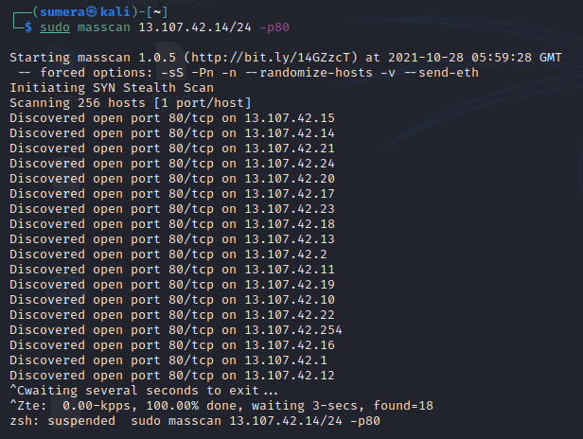

1. Attempt to scan without port no. showing error.

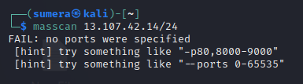

1. Performing masscan on linkedin.com on port no 80 with rate or speed of 10000.

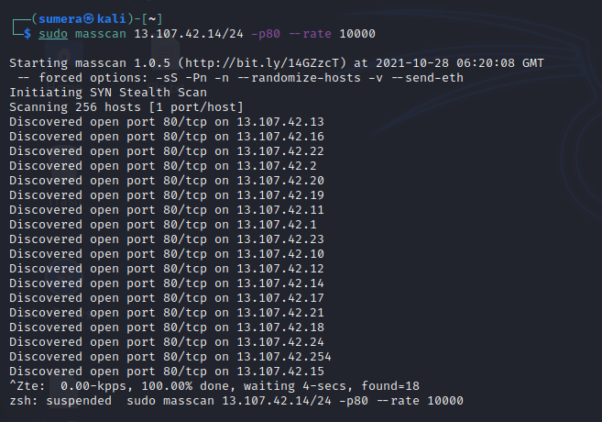

1. Packets are sent with speed that is –rate with specific port no.

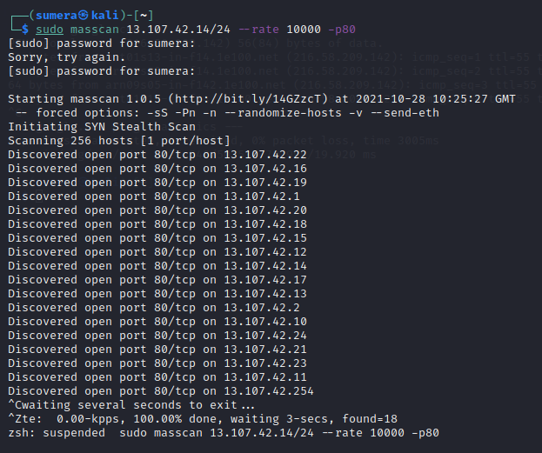

1. it uses a batch query that is exclude file containing ip.

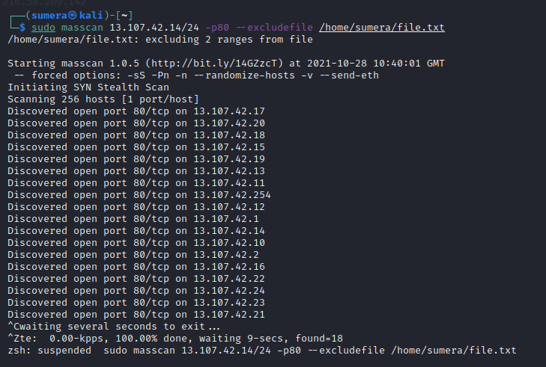

1. It includes the IP in the in file too even if they are not the part of subnet mask, if mention like in screenshot below.

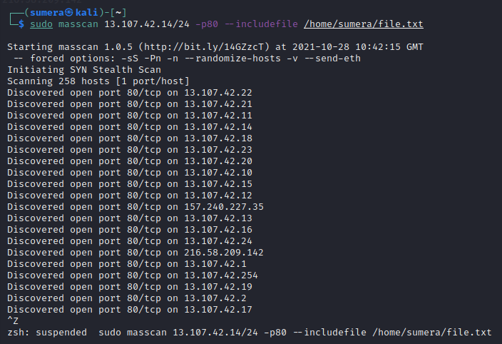

1. It can scan for the IP’s in file.

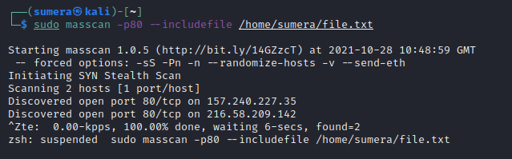

1. Storing the result in the oG file format.

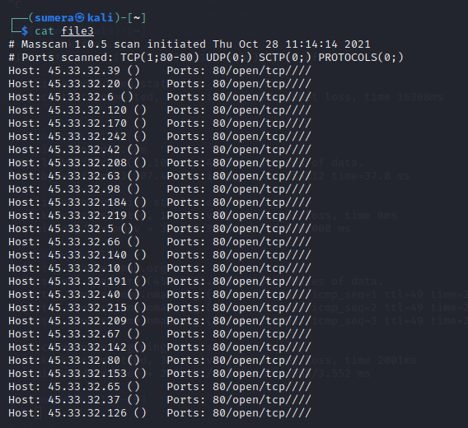

1. Creating of file using terminal and writing into file, to feed the file for command.

